**“SOLAR BOX”**

**Abstract**

Solar Box is a device useful for everyone. This device is mainly for the travelers who travel remote areas where there is no source of energy. This Solar Box contains different components which can convert solar energy into different forms of energy. Mainly this Solar Box contains different forms of energy like electrical, heat, wind, light which are basically needed energy forms. Solar Box is mainly designed in small size which is easy to carry around. It takes Solar energy to charge and converts it into different forms of energy.

**Introduction**

Solar Box is designed in such a way that we can use all options by using buttons for every component in it. Every instrument is assigned to a button. When you press a button its respective component will get energy from the Arduino and it will start to work.

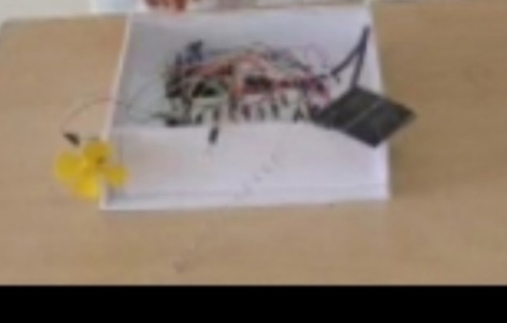

This mechanism allows us to use every component at a same time. It contains a fan, heater made up of resistors (we can use heating element of course), led light, a switch which can be used to use the converted energy. These components are hand picked because they are low cost and are capable of working up to the required level.

**Use cases**

This Solar Box model is more like a survival kit and can also be used by common people, which is exactly the sole reason of its creation. It can be used by anyone. It is because it is easy to use due to it’s button like operations which are basically understandable by everyone these days. It can be used by people who live in remote areas and whom don’t have electrical supply. It is a one time investment type, because when you buy it afterwards there is no need of any money because solar energy is free.

**Block diagram**

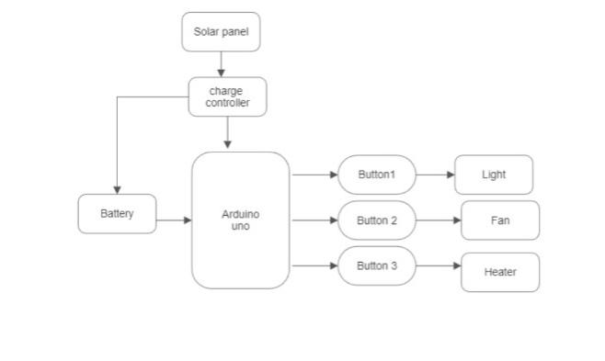

**Simulation** 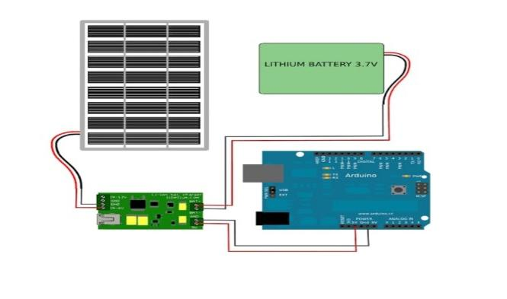

1. Initially the Arduino, lithium ion battery, charge controller and the solar panel are connected to each other.
2. All the components are connected to Arduino and respective buttons.
3. When certain button is pressed the Arduino will receive signals and pass electricity to it and the component will run and gives energy.
4. 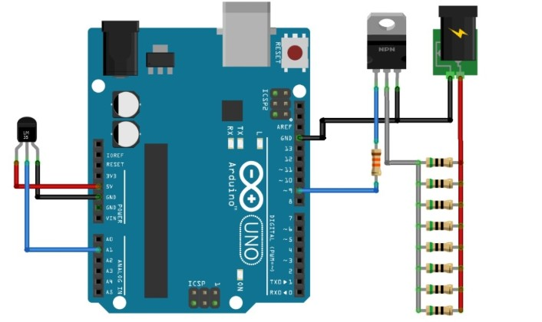For example the heater will have connection like below.
5. For example the motor and led and switch will have connection like below.

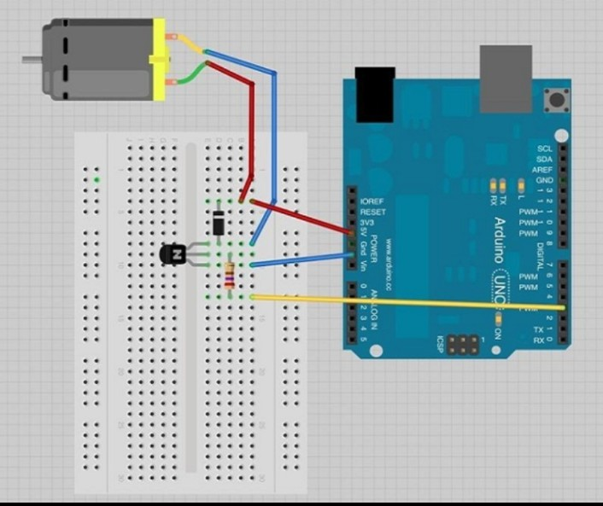

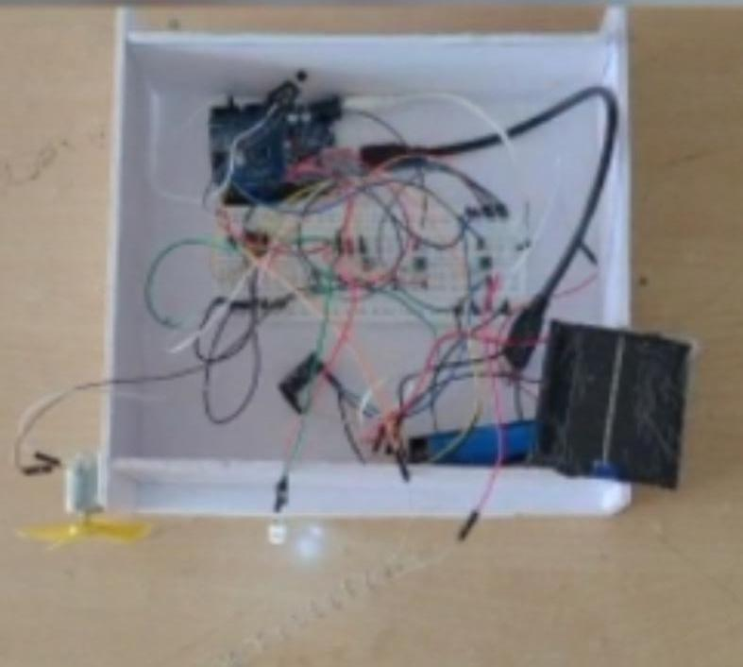**Final product**

**Conclusion**

This Solar box is very useful for travelers and also for normal people in their day-to-day life. Everyone can use this Solar Box because it’s more like an one time investment and the consumer can use it for the rest of their lives with no cost at all. This Solar Box costs up to $35. This is easy to use and can be easy to carry any where due to it’s more suitable and small size. So I conclude by saying that Solar Box is a very useful device which should be available in market.